Title of oral or poster presentation*
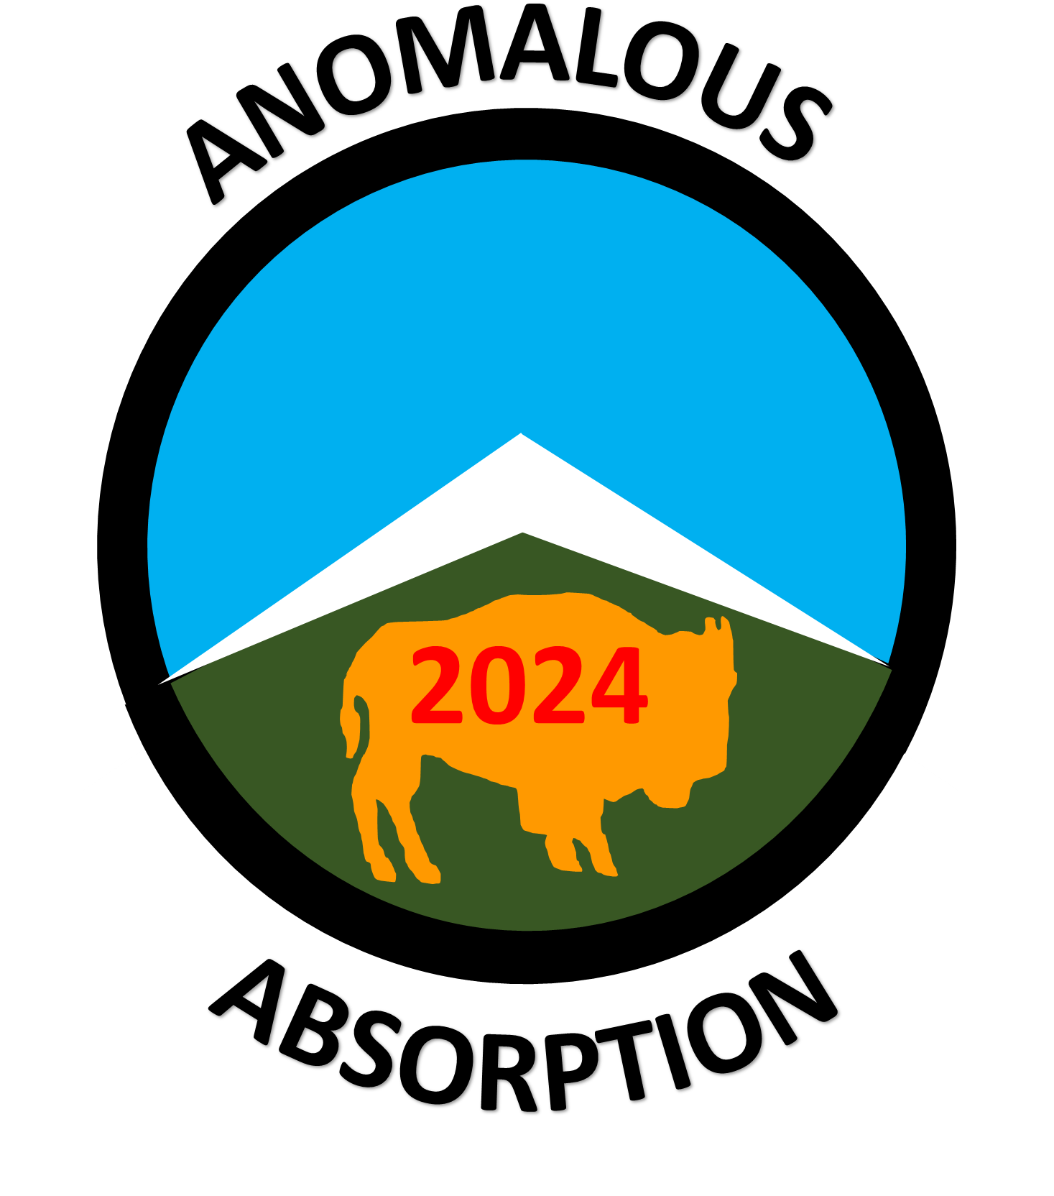

M. Y. Name, R. M. High, and D. E. Outsider†
Institution Name
Street address
City, State zipcode
contact-email@eserver
†Second institution if needed
Second City, State zipcode

This is the body of your abstract. It must fit on one page. Please save in PDF format and submit by emailing to AAC2024@AnomalousAbsorption.org. All abstracts must be received no later than May 9th, 2024.

You may have references and/or images in your abstract, but they must fit within the one page limit. Do not change the font sizes on this template. Please indicate in your email whether you prefer an oral or a poster presentation. If no preference is indicated, your presentation will most likely be assigned to a poster session. Final oral presentation selections will be decided by the technical organizing committee.

*This work conducted under the auspices…., if you have any. If not, then delete this line, and the asterisk at end of title.

M. J. Schmitt, L. Yin, and B. Wetherton, “Paper title,” Journal name Volume page (year).
D. H. Froula and A. Joglekar, University of Rochester, personal communication (year).

